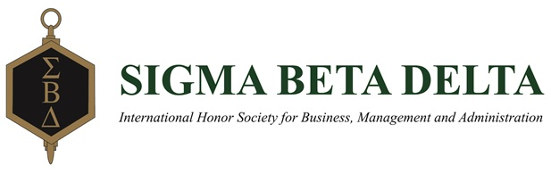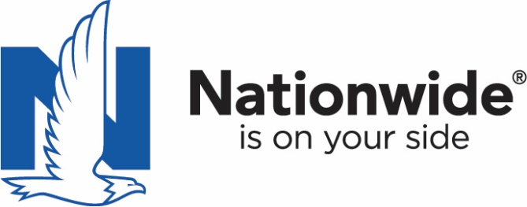

Nationwide Insurance Internship Application
Only students that became or will become Sigma Beta Delta members during the 2017-18 academic year are eligible to apply. Applications can be submitted anytime of the academic year but internships go fast so applying as soon as your interested is the best course of action. Submit the completed form to sigmabetadelta@umsl.edu.

Personal Information
Last Name:
First Name:
Current Address:
Address:
City:
State:
Zip:
Email:
Phone:

How did you hear about this internship?

Internship Department Preference: ☐Underwriting ☐Marketing ☐Information Technology
Internship Location Preference: ☐Columbus, OH ☐Des Moines, IA

Education
Name of Institution:
Major:
Anticipated graduation date:
GPA Overall:

Please list special skills or abilities:

Employment/Volunteer History
Company:
Address:
Position title:
Employed from (01/01/1001):
Employed to (01/01/1001):
Reason for leaving:
Supervisor name:
Supervisor phone:
May Nationwide contact this person as a reference? ☐Yes ☐No

Company:
Address:
Position title:
Employed from (01/01/1001):
Employed to (01/01/1001):
Reason for leaving:
Supervisor name:
Supervisor phone:
May Nationwide contact this person as a reference? ☐Yes ☐No

Personal Statement
Please provide a short (500 words max) personal statement of why you are interested in an internship, and how it fits your career goals.

Note: You may be requested to submit additional information.

By submitting this application, you are confirming that the information in it is complete, correct and accurate. Any misstatement or omission of fact on this application may result in the denial of your application or removal from Nationwide’s Internship Program.

Name: Date:

